MULTILINGUAL LANGUAGE TRANSLATION
A project report submitted in partial fulfillment of the requirements for the award
of the degree of

BACHELOR OF TECHNOLOGY

in

DEPARTMENT OF CSE – ARTIFICIAL INTELLIGENCE & MACHINE LEARNING

Submitted By

VEERI SRIMAHALAKSHMI - 22JN1A4241

BALLA LAKSHMI KALYANI - 22JN1A4245

SURAPUREDDY YEMINI BRAMARAMBA - 22JN1A4238

KUNKATLA GEETHIKA SAI SIVA POUNI - 22JN1A4266

GARLAPATI NAGALAKSHMI - 22JN1A4239



Under the Esteemed Guidance of

Ms. K.V. DURGA DEVI, M. Tech,

Assistant Professor

DEPARTMENT OF CSE – ARTIFICIAL INTELLIGENCE & MACHINE LEARNING

KAKINADA INSTITUTE OF ENGINEERING & TECHNOLOGY FOR WOMEN
(Approved by AICTE & Affiliated to JNT University Kakinada) Yanam Road, Korangi-533461, E.G. Dist. (A.P)
Phone no: 0884-234050, 2303400 Fax no: 0884-2303869
2022-2026

KAKINADA INSTITUTE OF ENGINEERING & TECHNOLOGY FOR WOMEN
(Approved by AICTE & Affiliated to JNT University Kakinada) Yanam Road, Korangi-533461, E.G. Dist. (A.P)
Phone no: 0884-234050, 2303400 Fax no: 0884-2303869
DEPARTMENT OF CSE – ARTIFICIAL INTELLIGENCE & MACHINE LEARNING



BONAFIDE CERTIFICATE

This is to certify that the project entitled “MULTILINGUAL LANGUAGE TRANSLATION” the bonafide record of work done by V.SRIMAHALAKSHMI, B.LAKSHMI KALYANI, S.YAMINI BRAMARAMBA, K.G.SAI SIVA POUNI, G.NAGALAKSHMI bearing with ROLL NO: 22JN1A4241, 22JN1A4245, 22JN1A4238, 22JN1A4266, 22JN1A4239 in partial fulfillment of the requirement for the award of the degree of BACHELOR OF TECHNOLOGY in Computer Science & Engineering-AIML in Kakinada Institute of Engineering & Technology For Women, Korangi, affiliated to Jawaharlal Nehru Technological University, KAKINADA.

INTERNAL GUIDE HEAD OF THE DEPARTMENT (Mr K. V. DURGA DEVI, M. Tech) (Ms M. DEEPIKA, M.Tech)
Assistant Professor Associate Professor
Department of CSE-AIML Department of CSE-AIML

EXTERNAL EXAMINER
ACKNOWLEDGEMENT

I would like to take the privilege of the opportunity to express my gratitude for the Project work of “MULTILINGUAL LANGUAGE TRANSLATION” which enabled us to express our special thanks to our honorable Chairman of the institution Sri. P.V. VISWAM.
I am thankful to Principal Prof. Y. RAMA KRISHNA, who has shown keen interest in us and encouraged us by providing all the facilities to complete my project successfully.
I express my gratitude to our beloved Head of the Department of CSE – AIML, Ms. M. DEEPIKA, M.Tech for assisting me in completing my project work.
I am extremely thankful to our Project Review Committee who has been a source of inspiration for us throughout my project and for their valuable advice in making my project a success.
I express my sincere thanks to my beloved supervisor Ms. K.V.DURGA DEVI, Assistant Professor, Dept. of CSE - AIML who has been a source of inspiration for me throughout my project and for his valuable pieces of advice in making my project a success.
I wish to express my sincere thanks to all teaching and non-teaching staff of the CSE – Artificial Intelligence & Machine Learning Department. I wish to express my special thanks to all the faculty members of our college for their concern in subjects and their help throughout my course.
I am very thankful to my parents, and all my friends who had given me good cooperation and suggestions throughout this project and helped me in successful completion.

VEERI SRIMAHALAKSHMI - 22JN1A4241

BALLA LAKSHMI KALYANI - 22JN1A4245

SURAPUREDDY YAMINI BRAMARAMBA - 22JN1A4238

KUNKATLA GEETHIKA SAI SIVA POUNI - 22JN1A4266

GARLAPATI NAGALAKSHMI - 22JN1A4239

DECLARATION

I am hereby declare that the project work entitled “MULTILINGUAL LANGUAGE TRANSLATION” submitted to the Kakinada Institute of Engineering and Technology For Women, affiliated to Jawaharlal Nehru Technological University Kakinada, is a record of the original work carried out by us under the guidance of Ms. K.V.DURGA DEVI, M.Tech., Assistant Professor in the Department of Computer Science and Engineering – ARTIFICIAL INTELLIGENCE & MACHINE LEARNING (CSE-AIML).This project work is submitted in partial fulfillment of the requirements for the award of the degree of Bachelor of Technology in Computer Science and Engineering – Artificial Intelligence & Machine Learning. The results embodied in this project have not been submitted to any other University or Institute for the award of any Degree or Diploma.

VEERI SRIMAHALAKSHMI - 22JN1A4241

BALLA LAKSHMI KALYANI - 22JN1A4245

SURAPUREDDY YAMINI BRAMARAMBA - 22JN1A4238

KUNKATLA GEETHIKA SAI SIVA POUNI - 22JN1A4266

GARLAPATI NAGALAKSHMI - 22JN1A4239

PlaceDate:

ABSTRACT

The rapid growth of global communication and digital content has increased the need for efficient and accurate multilingual language translation systems. Traditional translation methods often require manual effort, are time-consuming, and may lead to errors in understanding context and meaning. To address these challenges, this project proposes an innovative multilingual language translation system that leverages Artificial Intelligence and Natural Language Processing (NLP) techniques to enable seamless communication across different languages.

The system accepts text input from the user in one language and automatically translates it into the desired target language in real time. By utilizing advanced machine learning models and language processing algorithms, the system ensures accurate translation while preserving the original meaning, grammar, and context of the content.

This approach improves communication efficiency by reducing language barriers in education, business, travel, and digital communication platforms. It also enhances accessibility for users who need quick and understandable translations in their preferred language. The implementation involves language detection, text preprocessing, translation model integration, and output generation using AI-based libraries and APIs.

Overall, the proposed system provides an intelligent, efficient, and user-friendly alternative to manual translation methods, with potential applications in global communication platforms, educational tools, customer support systems, and multilingual content services.

TABLE OF CONTENTS

Chap No. | Title | Page No.
 | ABSTRACT | i
 | LIST OF FIGURES | iv
Chapter 1 | Introduction | 1 – 13
 | 1.1 Python | 3
 | 1.2 Artificial intelligence | 4
 | 1.3 Multilingual Language Translation | 5-6
 | 1.4 Natural Language Processing | 6-7
 | 1.4.1 Working of Natural Language Processing | 7-8
 | 1.4.2 History of Natural Language Processing | 9
 | 1.5 Machine Translation Techniques | 9-10
 | 1.6 Applications of Language Translation Systems | 10-11
 | 1.7 Translation Model Overview (e.g., Transformer Models / APIs) | 11-12
 | 1.8 Importance of Accurate and Responsible AI in Translation | 12-13
Chapter 2 | Literature Survey | 14-21
 | 2.1 Architecture | 16-17
 | 2.1.1 Neural Machine Translation Models | | 17
 | 2.2 Working of Language Translation Systems | 18-19
 | 2.3 Context-aware Translation Techniques | 19
 | 2.4 Language Detection and Preprocessing | 20
 | 2.5 Challenges in Multilingual Translation  2.6 Challenges in Multilingual Translation | 20-21  21
Chapter 3 | Aim and Scope of Present Investigation | 22-32
 | 3.1 Aim of the Project | 23-24
 | 3.2 Scope of the Project | 24-26
 | 3.3 System Requirements | 27-28
 | 3.4 Hardware Requirements | 28-29
 | 3.5 Software Requirements | 29-30
 | 3.6 Setup Instructions | 31-32
Chapter 4 | Project Implementation, Algorithm & Methodology | 33-43
 | 4.1 Introduction | 34
 | 4.2 Project Overview | 34-35
 | 4.3 System Architecture | 35-36
 | 4.4 Translation Model Integration (API / Pre-trained Models) | 36-37
 | 4.5 Text Preprocessing and Tokenization | 37-39
 | 4.6 Language Detection and Translation Flow | 39-41
 | 4.7 Methodology | 41-43
Chapter 5 | Results & Discussion | 44-55
 | 5.1 Summary | 45
 | 5.2 Results | 45-47
 | 5.3 Output Screens (Input Text, Language Detection, Translated Output) | 47-50
 | 5.4 Discussion | 51-55

CONCLUSION | 56-57
APPENDIX | 58-65

LIST OF FIGURES

FIGURE NO. | FIGURE NAME | PAGE NO
1.1 | Python | 4
1.2 | Artificial Intelligence | 5
1.3 | Multilingual Language Translation System | 6
1.4 | Natural Language Processing | 7
1.4.1 | Working of NLP | 8
1.4.2 | The History Of NLP | 9
2.1 | Language Translation System Architecture | 17
2.2 | Neural Machine Translation Workflow | 18
2.3 | Language Detection Mechanism | 20
5.1 | Directory Structure in VS Code | 47
5.2 | Application Home Interface | 48
5.3 | Language Selection Interface | 48
5.4 | User Input and Translated Output | 49
5.5 | Translation Result Display | 49

CHAPTER – I

INTRODUCTION

TITLE: Multilingual Language Translation System

In today’s fast-paced digital world, communication across different languages has become increasingly important among students, professionals, and global organizations. Language barriers often create difficulties in understanding information, sharing knowledge, and interacting effectively in multicultural environments. Traditional translation methods, such as manual translation or dictionary-based approaches, are often time-consuming, less accurate, and may fail to preserve the actual context of the content. Therefore, there is a need for an intelligent system that can provide real-time, accurate, and context-aware language translation.

The Multilingual Language Translation System is designed to provide users with a simple, interactive, and efficient platform where they can translate text from one language to another seamlessly. The system accepts user input in a source language and generates a translated output in the desired target language while maintaining the original meaning and context. By enabling fast and reliable translations, the system helps users overcome communication barriers and access information more easily.

Artificial Intelligence and Natural Language Processing play a major role in building intelligent translation systems that can understand and process human language effectively. NLP enables computers to analyze text input, detect language patterns, and generate meaningful translations. In this project, these technologies are combined with advanced machine learning models or translation APIs to provide accurate and context-aware language conversion.

The system is developed using Python and NLP-based libraries or APIs for backend processing. It performs text preprocessing, language detection, tokenization, and translation in real time. The modular design ensures that the system can handle multiple languages efficiently while maintaining performance and accuracy. The application may also support offline or API-based translation depending on implementation, ensuring flexibility and usability.

When a user provides input text, the system first processes and analyzes the language using language detection techniques. The text is then tokenized and passed through the translation model or API, which generates the translated output. The final result is displayed to the user in a clear and readable format. This structured workflow ensures smooth and accurate translation.

The application is developed in Visual Studio Code and follows a modular architecture so that new features such as voice translation, real-time speech conversion, and multilingual chat support can be easily integrated in the future.

In conclusion, the Multilingual Language Translation System provides an effective solution for overcoming language barriers and improving global communication. The project demonstrates how Artificial Intelligence and Natural Language Processing can be used to build intelligent, user-friendly, and scalable translation systems with practical real-world applications.

  - PYTHON
Python is a high-level, interpreted programming language known for its simplicity, readability, and extensive library support. It was created by Guido van Rossum and first released in 1991. Python’s easy syntax and modular structure make it one of the most widely used programming languages in artificial intelligence, machine learning, data science, and web development.

Python is widely used in modern AI-based systems because it provides powerful libraries and frameworks that simplify model development, data processing, and deployment. It supports multiple programming paradigms such as procedural programming, object-oriented programming, and functional programming.

One of the major advantages of Python is its rich ecosystem of libraries. In this project:
- NLP libraries / Translation APIs are used for language translation
- Transformers or pre-trained models are used for translation processing
- Flask or Streamlit is used for backend or web application integration
- NumPy and Pandas are used for text preprocessing and data handling
- Language detection libraries are used to identify input language
In this project, Python is used to develop the backend logic of the Multilingual Language Translation System. It handles user input, performs language detection, processes text data, applies translation models or APIs, and generates the translated output efficiently.


fig 1.2 :- Python

1.2 ARTIFICIAL INTELLIGENCE
Artificial Intelligence (AI) refers to the ability of computer systems to perform tasks that normally require human intelligence. These tasks include understanding language, learning from data, recognizing patterns, and generating decisions or outputs.

AI systems use algorithms, neural networks, and large datasets to simulate intelligent behavior. Artificial intelligence is widely used in applications such as virtual assistants, healthcare systems, recommendation engines, autonomous vehicles, and language translation systems.

In the Multilingual Language Translation System, AI is used to process input text, understand its context, and generate accurate translations in the target language. The system analyzes linguistic patterns and ensures that the translated output preserves the original meaning and context.
AI-powered translation systems can provide:
- Real-time language translation
- Improved communication across different languages
- Accurate and context-aware output
- Scalable and efficient processing
- User-friendly interaction
This makes AI highly useful in breaking language barriers and enabling global communication across various domains such as education, business, and digital platforms.


Fig 1. 2 :- Artificial Intelligence (AI)

1.3 MULTILINGUAL LANGUAGE TRANSLATION SYSTEM
A multilingual language translation system is an intelligent software application designed to convert text from one language to another while preserving its meaning and context. It enables users to communicate and understand information across different languages through automated translation.

These systems are widely used in education, business communication, travel, content creation, and digital platforms. Many modern translation systems use Natural Language Processing (NLP) and machine learning models to generate accurate and context-aware translations.

In this project, the Multilingual Language Translation System acts as a smart translation assistant. It accepts user input in one language, processes the text, and generates the translated output in the target language using AI-based translation techniques or APIs.

Advantages include:
- 24/7 availability
- fast and real-time translation
- easy communication across languages
- user-friendly interface
- reduced dependency on manual translation

This makes the system highly useful for students, professionals, and users who need quick and accurate translation for communication and understanding information.

1.4 NATURAL LANGUAGE PROCESSING (NLP)
Natural Language Processing (NLP) is a branch of artificial intelligence that focuses on the interaction between computers and human language. NLP enables machines to understand, interpret, and generate human language in a meaningful way.

NLP combines techniques from linguistics, computer science, and machine learning to process large amounts of textual data. It is widely used in applications such as chatbots, translation systems, sentiment analysis, speech recognition, and question answering systems.

In this project, NLP techniques are used to:
- preprocess user input
- tokenize the text
- detect the source language
- perform accurate language translation
- generate context-aware translated output

These techniques allow the system to process text efficiently and provide accurate translations while preserving the original meaning.

1.4.1 Working of NLP
The working of NLP in the Multilingual Language Translation System involves several steps:

Input Processing
The user enters text in a specific language into the application interface. This input forms the basis for further processing.

Text Preprocessing
The input text is cleaned by removing unnecessary characters, correcting formatting, and normalizing the text. This step ensures consistency and prepares the data for accurate translation.

Language Detection
The system identifies the source language of the input text using language detection techniques. This step is essential for selecting the appropriate translation model or API.

Tokenization
The processed text is broken down into smaller units called tokens. These tokens help the model understand the structure and meaning of the input text.

Translation Process
The tokenized input is passed to the translation model or API, which converts the text into the target language while preserving its context and meaning.

Output Generation
The translated tokens are converted back into readable text and displayed to the user as the final output.

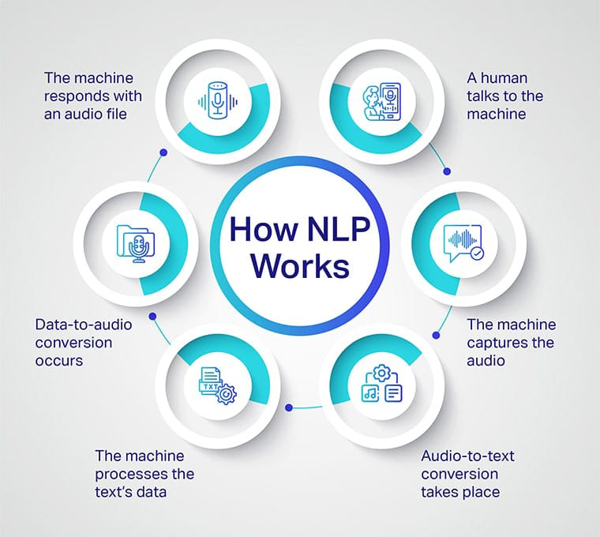
Fig 1.4.1:- Working of NLP

1.4.2 History of NLP
The history of Natural Language Processing dates back to the 1950s when researchers first began exploring the possibility of enabling computers to understand human language.

One of the earliest ideas related to artificial intelligence was the Turing Test, proposed by Alan Turing. This test aimed to determine whether a machine could exhibit intelligent behavior similar to a human.
In the early stages, NLP was mainly focused on rule-based translation systems, where predefined grammar rules were used to convert text from one language to another. These systems had limitations in handling complex language structures.

Over the years, NLP has evolved significantly with the development of machine learning and deep learning technologies. Statistical and neural machine translation methods improved the accuracy and efficiency of translation systems.

Today, advanced NLP models such as transformer-based architectures can understand complex language patterns and generate highly accurate and context-aware translations, making multilingual communication more efficient and accessible.

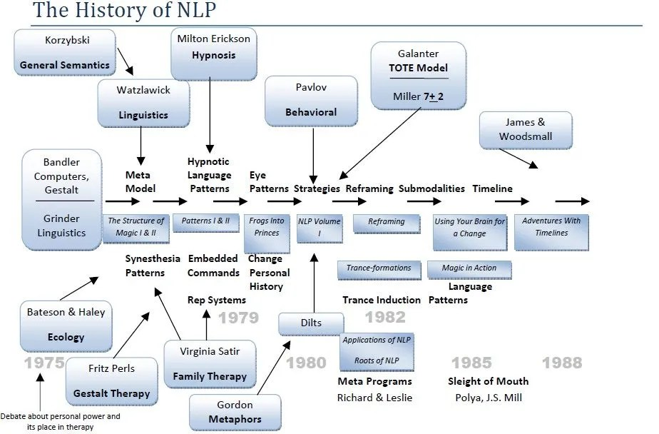
Fig 1.4.2:- THE HISTORY OF NLP

1.5 LARGE LANGUAGE MODEL
Large Language Models (LLMs) are advanced artificial intelligence systems trained on massive amounts of textual data to understand, generate, and process human language. These models use transformer-based neural network architectures and are capable of performing tasks such as text generation, summarization, translation, question answering, and language understanding.

LLMs learn language patterns, sentence structure, context, and semantic meaning from large datasets. Because of this, they can generate accurate and context-aware outputs, making them highly effective for multilingual language processing tasks.

In this project, the Multilingual Language Translation System uses Large Language Models or pre-trained translation models to perform accurate and context-aware language translation. These models help the system understand the input text, capture its meaning, and generate appropriate translations in the target language while maintaining context and fluency.

Large Language Models offer several advantages:

- accurate and context-aware translation
- understanding of complex language structures
- support for multiple languages
- ability to handle large-scale text data
- adaptability to different domains
- improved translation quality over traditional methods

This makes LLMs highly suitable for building intelligent multilingual language translation systems that enable effective communication across different languages.

1.6 APPLICATIONS OF AI IN LANGUAGE TRANSLATION SYSTEMS
Artificial Intelligence is playing an increasingly important role in the field of language translation by providing accurate, scalable, and real-time communication solutions across different languages.
AI-based language translation applications include:
- text translation systems
- real-time communication tools
- speech-to-text and text-to-speech translation
- multilingual chat applications
- content localization systems
- language learning assistants
- cross-border business communication platforms

In this project, AI is applied in the form of a Multilingual Language Translation System that provides automatic text translation between different languages. The system uses Natural Language Processing and machine learning models or APIs to generate accurate and context-aware translations, helping users understand and communicate effectively.

AI-based translation solutions are highly beneficial because they provide:
- 24/7 availability
- fast and real-time translation
- high accuracy and context preservation
- easy access to multilingual information
- reduced manual effort
- improved global communication
This demonstrates how Artificial Intelligence can be used to break language barriers and enable efficient communication across various domains such as education, business, and digital platforms.

1.7 TINYLLAMA MODEL OVERVIEW
TinyLlama is a lightweight large language model designed to provide efficient text generation and conversational capabilities with lower computational requirements. It follows the transformer decoder architecture, making it suitable for natural language processing tasks such as translation, summarization, and multilingual understanding.
In this project, the TinyLlama-1.1B-Chat model is used as the base model for the Multilingual Language Translation System. The model is fine-tuned using LoRA (Low-Rank Adaptation) to specialize it for accurate language translation across multiple languages while maintaining contextual meaning.
The TinyLlama model offers several advantages for multilingual translation applications:
- lightweight architecture
- low memory usage
- CPU-friendly inference
- faster response generation
- easy fine-tuning with LoRA
- local offline deployment
These features make it ideal for real-time, privacy-focused translation systems where efficiency and speed are important.
The model is capable of:
- understanding input text in multiple languages
- translating text between different languages accurately
- maintaining semantic and contextual meaning
- handling conversational and formal text
- working efficiently in local environments without heavy computational resources
This makes TinyLlama highly suitable for the Multilingual Language Translation System project, especially for scalable and accessible translation solutions.

1.8 IMPORTANCE OF RESPONSIBLE AI IN MULTILINGUAL LANGUAGE TRANSLATION
Responsible AI is extremely important in multilingual language translation systems because the model processes user-generated text across different languages, cultural contexts, and sensitive meanings. Incorrect or biased translations can lead to misunderstanding, misinformation, or inappropriate communication.

In multilingual translation systems, AI must ensure:

- accurate and context-preserving translations
- bias-free language handling
- cultural sensitivity in output text
- privacy protection of user input data
- safe and neutral language generation

In this project, responsible AI principles are followed to ensure that the translation output remains neutral, respectful, and contextually correct across multiple languages. Input text is processed carefully to avoid misinterpretation or offensive translations.

Responsible AI ensures:
- ethically correct translations
- unbiased multilingual communication
- user trust and safety in translated content
- reduced risk of miscommunication across languages
- privacy-friendly text processing

This makes Responsible AI an important component of the Multilingual Language Translation System, ensuring that translations are not only accurate but also safe and culturally appropriate.

CHAPTER - II

LITERATURE SURVEY

Literature Survey is one of the most important stages in the software development process. Before developing any software system, it is necessary to study existing technologies, research papers, and previously developed systems related to the project. This helps developers understand the available solutions, identify limitations, and design a better system.

During the literature survey stage, several factors such as time, cost, available resources, system requirements, and development tools are analyzed. It also helps in selecting the appropriate programming language, development environment, and framework for building the proposed system.

For the development of the Multilingual Language Translation System, various studies related to Artificial Intelligence, Natural Language Processing (NLP), machine translation systems, transformer models, and large language models were analyzed. These studies provide insights into how AI systems can translate text accurately between different languages while preserving meaning and context.

In recent years, the demand for intelligent multilingual communication systems has increased rapidly. Many researchers have focused on developing AI-based translation platforms and language assistants that enable real-time translation of text and speech across multiple languages.

Several research studies highlight the importance of AI-driven translation systems in breaking language barriers, improving global communication, and enhancing accessibility. These systems use NLP techniques, sequence-to-sequence models, and transformer-based architectures to understand and translate human languages effectively.

Some research works focused on neural machine translation (NMT) systems that use deep learning models to improve translation quality. These systems help in generating more natural and context-aware translations compared to traditional rule-based approaches.

Another major area explored in literature is the use of Transformer-based architectures and Large Language Models (LLMs) for multilingual translation. These models enable systems to learn relationships between languages and generate high-quality translations across diverse linguistic structures.

Researchers have also experimented with techniques like attention mechanisms and fine-tuning using LoRA (Low-Rank Adaptation) to improve translation accuracy and efficiency. These methods help reduce computational requirements while maintaining performance.
Studies also highlight the importance of lightweight and offline translation systems, especially for low-resource environments. Technologies such as Python, PyTorch, Hugging Face Transformers, and LoRA fine-tuning are widely used for building scalable and efficient multilingual systems.

Despite these advancements, many existing systems still face limitations such as lack of offline support, high computational cost, dependency on cloud APIs, and reduced performance for low-resource languages. Therefore, developing a lightweight multilingual translation system using TinyLlama and LoRA helps address these challenges.

The proposed system aims to create an efficient and user-friendly translation platform where users can translate text between multiple languages accurately while maintaining context, meaning, and linguistic correctness.

2.1 ARCHITECTURE
The architecture of the Multilingual Language Translation System follows a structured workflow that includes several modules such as user interaction, input processing, tokenization, TinyLlama inference, language translation processing, and response generation.

The major components include:
User Interface
The user interface allows users to interact with the system through a simple text-based input system where users can enter text in any supported language and receive translated output.

Input Processing Module
This module receives the user’s input text and prepares it for processing by cleaning and standardizing the text format.

Tokenizer Module
The TinyLlama tokenizer converts the input text into tokens that can be understood by the model for processing multilingual language patterns.

LLM Inference Module
The fine-tuned TinyLlama-1.1B-Chat model processes the tokenized input and generates intermediate language representations required for translation.

Translation Processing Module
This module performs the core task of converting input text from one language to another while preserving meaning, grammar, and context.

Safety and Quality Control Module
This module ensures that the translated output is contextually correct, unbiased, and linguistically appropriate across different languages.

Response Output
The final translated text is displayed to the user in the selected target language through the interface.
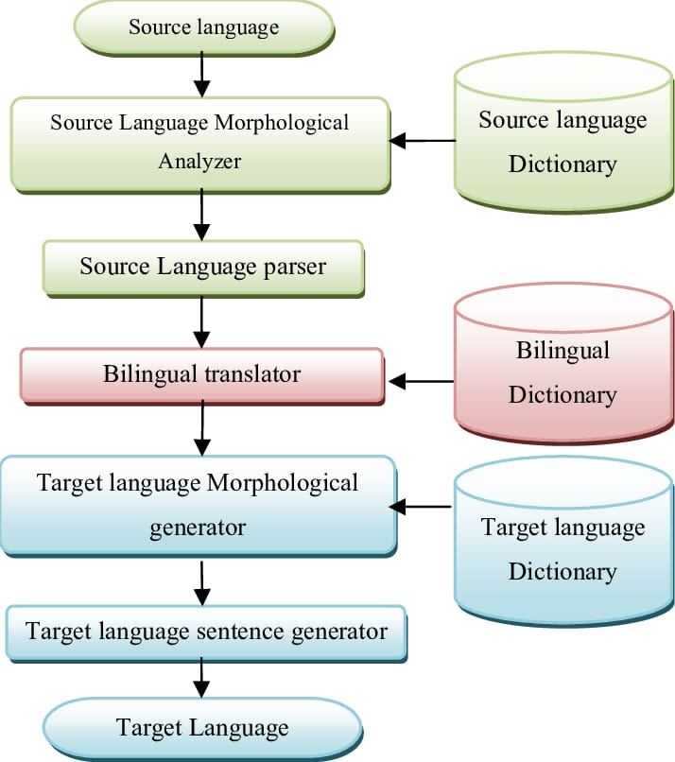

2.1.1 LLM-Based Conversational Support Systems
Large Language Model (LLM)-based translation systems are advanced AI applications that use transformer architectures to understand and generate human-like text across multiple languages.
In this project, the TinyLlama-1.1B-Chat model is used as the core LLM for the Multilingual Language Translation System. The model is fine-tuned using LoRA adapters, enabling efficient adaptation for multilingual translation tasks while maintaining contextual and semantic accuracy.

The main steps involved include:
- user text input in any supported language
- tokenization of input text
- language understanding and context extraction
- translation generation using the LLM
- quality and consistency checking
- translated output display
This approach helps the system maintain contextual accuracy, grammatical correctness, and meaning preservation across different languages.

2.2 WORKING OF MULTILIGUAL LANGUAGE TRANSLATION SYSTEM

The working of the system involves several steps:
Step 1: User Input
The user enters text in any supported source language that needs to be translated.

Step 2: Text Preprocessing
The input text is cleaned, normalized, and prepared for processing to ensure consistency and accuracy.

Step 3: Tokenization
The TinyLlama tokenizer converts the input text into token IDs that the model can understand.

Step 4: Model Inference
The fine-tuned TinyLlama-1.1B-Chat model processes the tokenized input and understands the contextual meaning of the sentence.

Step 5: Translation Generation
The model generates the equivalent translated text in the selected target language while preserving meaning and grammar.

Step 6: Output Display
The final translated text is displayed to the user in the chosen language through the interface.

2.3 CONTEXT-AWARE TRANSLATION GENERATION
Context-aware translation generation refers to the system’s ability to understand the meaning, context, and linguistic structure of the input text and generate an accurate translation accordingly.

The system analyzes whether the input text is:
- formal or informal
- simple or complex
- conversational or technical
- single-sentence or multi-sentence context
- language-dependent expressions or idioms

Based on the detected context and structure, the TinyLlama-1.1B-Chat model generates translations that are more accurate, natural, and contextually appropriate.

This improves:
- translation accuracy
- contextual understanding
- multilingual consistency
- user trust in output
- overall translation quality

This approach ensures that the translated output is not just word-to-word conversion but a meaningful and grammatically correct representation in the target language.

2.4 SAFETY AND QUALITY ASSURANCE MECHANISMS
Safety and quality assurance mechanisms are important in multilingual translation systems to ensure that generated translations are accurate, appropriate, and contextually correct.
The system includes text validation and quality control techniques that detect and handle:
- ambiguous sentences
- incorrect grammar structures
- mixed-language inputs
- culturally sensitive expressions
- misleading or unclear translations

When such cases are detected, the system ensures that the output is refined or reprocessed to maintain translation quality and correctness.

This mechanism improves:
- responsible AI usage
- linguistic accuracy
- translation consistency
- user trust
- high-quality multilingual output

This ensures that the system generates translations that are not only linguistically correct but also clear, meaningful, and contextually appropriate.

2.5 FUTURE SCOPE OF MULTILINGUAL LANGUAGE TRANSLATION SYSTEM
The Multilingual Language Translation System can be enhanced with several advanced features in the future to improve accuracy, usability, and global accessibility.
Real-Time Speech Translation
Future systems can support live speech-to-speech translation for seamless multilingual communication.
Improved Context Understanding
Advanced models can be integrated to better understand long sentences, idioms, and cultural expressions.
Voice-Based Translation Support
The system can be extended to support voice input and audio output for hands-free translation.
Offline Translation Mode
Future versions can support fully offline translation for low-network or remote areas.
Multilingual Chat Integration
The system can be integrated into chat applications for real-time multilingual conversations.
Language Expansion
More regional and low-resource languages can be added to improve accessibility.
Mobile Application Deployment
The system can be developed as an Android or iOS application for easy access anywhere. This future scope makes the system more powerful, scalable, and useful for global communication across different languages.

CHAPTER – III

AIM AND SCOPE OF PRESENT INVESTIGATION

3.1 AIM

The main aim of this project is to develop an intelligent Multilingual Language Translation System that helps users translate text between multiple languages accurately, efficiently, and in real time while preserving the meaning and context of the original input.

In today’s globalized world, communication across different languages is a major requirement in education, business, travel, and online interactions. Language barriers often create misunderstandings and limit access to information. Many existing translation tools depend heavily on cloud-based APIs, which may require internet connectivity, raise privacy concerns, or fail to provide context-aware translations. Therefore, there is a need for a lightweight, efficient, and reliable multilingual translation system.

The proposed system is designed to act as a real-time language translation assistant that allows users to input text in one language and receive an accurate translation in another language through a simple interface. The system processes the input text and generates context-aware translations using the TinyLlama-1.1B-Chat model fine-tuned with LoRA (Low-Rank Adaptation).

This project uses technologies such as Artificial Intelligence, Natural Language Processing (NLP), Python, PyTorch, Hugging Face Transformers, and Flask to build an interactive and user-friendly platform. The backend is developed using Python-based AI libraries, while the frontend is implemented using HTML, CSS, and JavaScript, enabling a smooth web-based translation experience.

Another important aim of the project is to make language translation accessible to everyone. Users can translate text anytime without relying on complex tools or external APIs, ensuring better privacy and potential offline usage. This increases flexibility and usability across different environments such as education, communication, and professional use.

The system also focuses on maintaining translation quality and responsible AI usage. It ensures that the generated translations are contextually correct, grammatically accurate, and culturally appropriate across multiple languages.

Overall, the Multilingual Language Translation System aims to:
- Provide accurate and real-time multilingual translation
- Break language barriers for global communication
- Ensure context-aware and meaningful translations
- Improve accessibility through a simple user interface
- Enable lightweight and efficient AI-based translation
- Support privacy-friendly and scalable language processing
By achieving these objectives, the project demonstrates how Generative AI and Large Language Models can be effectively used for building intelligent multilingual communication systems that benefit global users.

3.2 SCOPE
The scope of the Multilingual Language Translation System focuses on providing an intelligent and automated language translation platform that enables users to convert text from one language to another accurately, efficiently, and in real time.

This project mainly deals with text-based multilingual translation, where users enter input text in any supported language through a web interface. The system processes the input and generates an equivalent translation in the target language while preserving meaning, grammar, and context.

The scope of this project includes several important aspects of natural language processing and multilingual communication systems.

Multilingual Communication Support
The system provides a platform where users can communicate across different languages without language barriers. This is useful in education, travel, business communication, and global interaction.

Context-Aware Translation
The application uses a TinyLlama-based large language model fine-tuned with LoRA, which helps in generating context-aware and meaningful translations rather than direct word-to-word conversion.

Language Processing and Tokenization
The system processes input text using NLP techniques such as tokenization and contextual embedding to understand sentence structure before translation.

Web-Based Interface
The system is developed as a web application using the Flask framework. This allows users to access the translation system through a browser without installing additional software. The interface is simple, interactive, and user-friendly.

User Experience
The project focuses on providing a smooth and efficient user experience. The interface includes:
- text input area
- language selection options
- translation output display
- history or response view
- simple and responsive UI
- Real-Time Translation Support
The system is designed to provide quick and efficient translations, making it suitable for real-time communication scenarios.

Future Scope
Although the current system focuses on text-based translation, it can be enhanced in the future with advanced features such as:
- speech-to-text and text-to-speech translation
- real-time conversation translation
- mobile application integration
- offline translation mode
- support for more regional and low-resource languages
- AI-powered grammar correction in translations
- multilingual chat integration

The system can also be extended for various real-world applications such as:
- educational learning platforms
- international business communication tools
- travel and tourism assistance
- social media translation support
- cross-language customer support systems

Another future improvement could include adaptive translation models, where the system learns user preferences and improves translation style over time for better personalization.
In conclusion, the scope of the Multilingual Language Translation System is to provide a reliable, scalable, and intelligent AI-based translation platform that helps users overcome language barriers and enables smooth global communication using modern NLP and Generative AI technologies.

3.3 SYSTEM REQUIREMENTS
A successful implementation of the Multilingual Language Translation System requires a suitable combination of hardware and software components. Below are the system-level requirements necessary for development, model loading, inference, and execution of the translation system.

Development Environment
For the development environment, Visual Studio Code (VS Code) is recommended as it is a powerful and extensible code editor suitable for AI-based and web development projects. It provides features such as syntax highlighting, debugging, terminal integration, and extension support, which help in efficient development.
Jupyter Notebook can also be used as an optional environment for testing translation outputs, experimentation, and model evaluation.

Programming Language
The primary programming language used for this project is Python 3.x, chosen for its simplicity, readability, and strong support for Artificial Intelligence and Natural Language Processing applications. Python provides a rich ecosystem of libraries required for building multilingual translation systems.

AI and NLP Tools
For implementing the translation intelligence, the project uses PyTorch for deep learning model loading and inference. The Hugging Face Transformers library is used for loading the TinyLlama model, tokenizer, and text generation pipeline.
For efficient adaptation, PEFT with LoRA (Low-Rank Adaptation) is used to fine-tune the model for multilingual translation tasks without retraining all parameters.

Text Processing
The tokenizer plays a crucial role in converting input text into token IDs that can be processed by the model. Proper tokenization ensures accurate understanding of sentence structure, grammar, and context for better translation quality.

Operating System
The operating system for development can be Windows, Linux, or macOS, as Python and the required AI libraries are cross-platform compatible. This provides flexibility for both development and deployment environments.

Deployment Tools
For deployment, the project uses the Flask framework, a lightweight Python web framework used to create the backend of the translation system. Flask manages user requests, language selection, translation processing, and output rendering.

An optional Streamlit interface can also be used for rapid prototyping and demonstration purposes.
These specifications collectively ensure a smooth development process, efficient multilingual translation, context-aware output generation, and scalable deployment of the Multilingual Language Translation System.

3.4 HARDWARE REQUIREMENTS
To efficiently run the Multilingual Language Translation System, the hardware should be capable of loading the TinyLlama model, processing user input text, and generating translations in real time. Since the project uses a lightweight TinyLlama model with LoRA fine-tuning, the hardware requirements are moderate and suitable for local systems.

Processor
For effective development and local model inference, a multi-core processor is essential. A minimum of an Intel Core i3 or equivalent is sufficient for basic execution and testing. However, a more powerful processor such as Intel Core i5 or i7 (or AMD equivalents) is highly recommended for faster translation generation and smoother performance. A better processor significantly reduces the time required for tokenization, inference, and output generation.

RAM
Sufficient Random Access Memory (RAM) is critical for smooth system performance, especially when loading the TinyLlama model and tokenizer into memory. A minimum of 4 GB RAM is required for basic execution, but 8 GB or more is strongly recommended for optimal performance. Higher RAM allows efficient handling of model processing, user input, and translation output without delays or memory issues.

Storage
Adequate storage space is required to store:
- TinyLlama model files
- LoRA adapter weights
- tokenizer files
- project source code
- Flask templates and static files

A minimum of 1 GB storage is sufficient for basic setup. However, it is recommended to have at least 2 GB or more free storage for future enhancements such as additional language support, datasets, and logging features. Using an SSD (Solid State Drive) instead of an HDD improves model loading speed and overall system performance.
These hardware specifications ensure that the system runs smoothly, supports efficient multilingual translation, and delivers fast, real-time language conversion with minimal latency.

3.5 SOFTWARE REQUIREMENTS
This section outlines the necessary software, frameworks, and packages required to build and run the Multilingual Language Translation System application.

Python (Version 3.9 or higher)
Python is the primary programming language used for backend development, model integration, and implementation of multilingual translation logic.

Pip - pip is the package installer for Python, used to install and manage all required libraries and project dependencies.

IDE: Visual Studio Code or Jupyter Notebook
Visual Studio Code is used for full project development, Flask integration, and managing frontend-backend workflow.
Jupyter Notebook can be used for testing TinyLlama outputs, experimenting with translation results, and evaluating model performance.

Browser: Chrome / Firefox
A web browser is required to access and test the translation interface when the system is deployed using Flask.
Libraries

PyTorch (torch)
Used for deep learning model loading, tensor operations, and running TinyLlama inference for translation tasks.

Hugging Face Transformers (transformers)
Used for loading the TinyLlama model, tokenizer, and managing the text generation pipeline for multilingual translation.

PEFT (peft)
Used for integrating LoRA (Low-Rank Adaptation), enabling efficient fine-tuning for multilingual translation without retraining the full model.
Streamlit
Used for frontend/backend development, handling user requests, language input processing, and deploying the translation system as a web application.

NumPy (numpy)
Used for numerical computations and supporting tensor-based operations during model processing.

Pandas (pandas)
Used for optional dataset handling, preprocessing, and analyzing translation outputs or logs.
These software requirements ensure that the system supports efficient multilingual translation, real-time inference, web-based deployment, and scalable AI-based language processing..

3.6 SETUP INSTRUCTIONS
Below are the step-by-step setup instructions to get the Multilingual Language Translation System running locally.

Step 1: Install Python
Download and install Python 3.9 or above from the official Python website:
https://www.python.org/⁠

Step 2: Create a Virtual Environment (Optional)
Create and activate a virtual environment for isolated dependency management.
Bash
# On Windows
python -m venv TRANSLATION_ENV
TRANSLATION_ENV\Scripts\activate

Step 3: Install Required Libraries
Open the terminal and run:
Bash
pip install torch transformers peft flask numpy pandas streamlit

Step 4: Download / Setup Project Files
Ensure the project folder contains the following files:
backend (Flask application files)
templates (HTML files)
static (CSS/JS files)
model files (TinyLlama + LoRA adapters)
tokenizer configuration files
app.py (main execution file)

Step 5: Run the Application
Navigate to the backend directory and run the application.
Bash
cd backend
streamlit run app.py

Step 6: Access Application
Open a web browser and go to:

http://localhost:8501

This launches the Multilingual Language Translation System interface, where users can input text in one language and receive translated output in real time.
This setup ensures smooth local execution, efficient model loading, and real-time multilingual translation using the TinyLlama-based system.

CHAPTER IV

PROJECT IMPLEMENTATION, ALGORITHMS AND METHODOLOGY

4.1 INTRODUCTION

This chapter describes the implementation process of the Multilingual Language Translation System. It explains the technologies, algorithms, and methodology used to design and develop the system.

The main objective of this project is to develop an intelligent language translation system that can convert text from one language to another accurately and efficiently. The system allows users to input text in a source language and receive a translated output in the selected target language in real time.

The system uses Artificial Intelligence (AI) and Natural Language Processing (NLP) techniques to understand the input text and generate appropriate translations. NLP helps the system interpret human language, while the TinyLlama language model is used to generate context-aware and meaningful translations across multiple languages.

The implementation of the system involves multiple stages such as data preprocessing, tokenization, model inference, translation generation, and output display. These stages ensure that the system works efficiently and provides accurate and context-preserving translations to users.

By implementing this system, users can easily translate text between different languages, which helps in improving communication, reducing language barriers, and enhancing global accessibility

4.2 PROJECT OVERVIEW

The Multilingual Language Translation System is designed to perform accurate and context-aware translation of text between multiple languages using an AI-based conversational model.
The system works through a structured workflow that includes the following stages:
- The user accesses the translation system through a web-based interface developed using Streamlit or Flask.
- The user enters text in a source language through the input interface.
- system processes the input using preprocessing techniques such as normalization and tokenization.
- The processed input is passed to the fine-tuned TinyLlama-1.1B-Chat model.
- The model generates a translated output based on learned multilingual language patterns and contextual understanding.
- The translated response is displayed back to the user in real time in the selected target language.

The application is developed using the Python programming language. Streamlit/Flask is used to create an interactive user interface, while the backend logic handles model loading, tokenization, and inference. The TinyLlama model is fine-tuned using LoRA (Low-Rank Adaptation) to improve performance for multilingual translation tasks.
The system provides a simple and user-friendly interface where users can translate text between different languages easily, without complexity, ensuring fast and efficient communication across language barriers.

4.3 SYSTEM ARCHITECTURE

The Multilingual Language Translation System follows a layered architecture to ensure smooth communication between components and efficient translation processing.

System Flow:
User Input → Web Interface → Input Processing → Tokenization → TinyLlama Model → Translation Generation → Output Display

System Components:

1. User Interface Layer (Streamlit / Flask):
This layer is responsible for taking input text from the user and displaying the translated output. It provides a simple and interactive interface where users can select source and target languages.

2. Input Processing Layer:
This layer processes the raw input text by cleaning, normalizing, and preparing it for model inference. It ensures that the text is properly formatted for accurate translation.

3. Tokenization Layer:
This layer converts the processed input text into token IDs using the TinyLlama tokenizer. These tokens are essential for model understanding and processing of multilingual data.

4. AI Model Layer (TinyLlama):
This is the core component of the system. The fine-tuned TinyLlama-1.1B-Chat model generates context-aware and meaningful translations based on the input tokens.

5. Translation Generation Layer:
This layer interprets the model output and converts it into human-readable translated text in the selected target language.

6. Output Layer:
The final translated text is displayed to the user through the web interface in real time, ensuring smooth and efficient multilingual communication.

This layered architecture ensures efficient processing, accurate translation, and a user-friendly experience in the Multilingual Language Translation System.

4.4 TINYLLAMA MODEL FINE-TUNING USING LORA

The TinyLlama-1.1B-Chat model is used as the base large language model in this project. Since the original model is trained on general-purpose data, it is not specifically optimized for multilingual translation tasks. Therefore, fine-tuning is required to adapt the model for accurate and context-aware language translation.
To achieve efficient fine-tuning, the LoRA (Low-Rank Adaptation) technique is used. LoRA is a parameter-efficient fine-tuning method that modifies only a small number of trainable parameters while keeping most of the pre-trained model weights frozen. This significantly reduces computational cost and memory usage while maintaining high performance.

In this project, LoRA is applied to the attention layers of the TinyLlama model. Instead of retraining the entire model, small low-rank matrices are introduced into the transformer architecture. These matrices learn multilingual translation patterns from the training dataset.

The fine-tuning process involves the following steps:
- The pre-trained TinyLlama model is loaded from the Hugging Face repository.
- LoRA configuration is applied to selected transformer layers.
- A multilingual dataset containing parallel text pairs (source and target languages) is used for training.
- The model is trained to generate accurate, context-aware translations between different languages.
- After training, the LoRA adapters are saved separately or merged with the base model for inference.

The fine-tuned model is then stored in the models/fine_tuned_tinyllama directory and integrated into the translation system for real-time inference.

The main advantage of using LoRA is that it enables faster training and lower hardware requirements, making it suitable for lightweight systems. After fine-tuning, the model shows improved multilingual understanding and generates more accurate and context-preserving translations compared to the base model.

4.5 TOKENIZATION AND TRANSLATION GENERATION

Tokenization and translation generation are key processes in the Multilingual Language Translation System that enable the conversion of user input text into accurate and meaningful translated output. These processes are essential for understanding natural language and generating context-aware translations using the TinyLlama language model.
Tokenization Process
Tokenization is the process of converting input text into smaller units called tokens. Since machine learning models cannot directly understand raw text, the input must be transformed into a numerical format before processing.
In this system, the tokenizer associated with the TinyLlama model is used to perform tokenization. The user input is first received through the web interface and then passed to the tokenizer.

The tokenization process includes the following steps:
- The user enters a text message in the source language.
- The input text is passed to the tokenizer.
- The tokenizer splits the sentence into tokens (words or sub-words).
- Each token is converted into a numerical representation (token IDs).
- These token IDs are passed to the model for processing.

Tokenization ensures that the textual input is converted into a format that can be understood by the transformer-based architecture of the TinyLlama model.

Translation Generation Process
After tokenization, the processed input is fed into the fine-tuned TinyLlama model for translation generation. The model uses an autoregressive generation approach, where output is generated step-by-step based on contextual understanding of the input text.

The translation generation process includes the following steps:
- The tokenized input is passed to the TinyLlama model.
- The model processes the input using transformer layers.
- It understands the context and meaning of the sentence.
- The model generates the equivalent translation in the target language.
- The generated tokens are decoded back into human-readable text.

Working Example

User Input (English):
“I feel very anxious about my future”

Translated Output (Telugu Example):
“నా భవిష్యత్తు గురించి నేను చాలా ఆందోళనగా ఉన్నాను”

Importance in the System
- Tokenization and translation generation are crucial because:
- They enable the model to understand human language
- They convert text into machine-readable format
- They generate accurate and context-aware translations
- They ensure smooth multilingual communication flow in the system

4.6 TRANSLATION SAFETY AND QUALITY FILTERING

Since the Multilingual Language Translation System processes user-generated text across different languages, implementing a safety and quality mechanism is an important part of the system. The purpose of this module is to ensure that the system produces accurate, appropriate, and contextually correct translations without generating misleading or incorrect outputs.
The system incorporates a simple yet effective input validation and filtering mechanism to detect problematic or ambiguous text before translation. This helps in maintaining translation quality and consistency across multiple languages.

4.6.1 Input Validation Approach
The input validation system works by analyzing the user input for:
- empty or incomplete sentences
- mixed or unsupported language inputs
- ambiguous or unclear text structures
- excessive special characters or noise
- malformed or non-grammatical sentences

These checks help ensure that only clean and meaningful text is passed to the translation model.
Working Mechanism
The working of the input validation system is as follows:
- The user enters a sentence in the translation interface.
- The input text is analyzed for formatting issues and validity.
- If the input is valid, it is processed normally by the TinyLlama model.
- If the input is invalid or unclear, it is cleaned or reprocessed before translation.
- The validated input is then passed for tokenization and translation generation.
- This ensures that the system produces reliable and high-quality translations.

4.6.2 Output Quality Handling
After translation, the system ensures that the generated output is checked for readability and correctness. The system ensures that:
- the translated sentence is grammatically correct
- meaning is preserved from the source language
- output is contextually appropriate
- no incomplete or broken sentences are generated
- If required, the system can re-generate or refine the translation for better accuracy.

Importance of Safety and Filtering Mechanism
The safety and filtering module is important because:
- It ensures accurate and reliable translations
- It prevents incorrect or meaningless outputs
- It improves overall translation quality
- It enhances user trust in the system
- It ensures responsible use of AI in multilingual processing

Limitations
Although effective, the current approach has some limitations:
- It may not fully understand complex linguistic ambiguity
- It relies on rule-based validation techniques
- It may require advanced NLP models for better contextual error detection
- It may need improvement for low-resource languages

4.7 METHODOLOGY

The methodology followed in the development of the Multilingual Language Translation
System includes several important stages that ensure accurate, efficient, and context-aware translation between multiple languages.
- Dataset Collection

The first step in the project is collecting and preparing a multilingual dataset for translation tasks.

This dataset includes:

- Parallel sentences in multiple languages

- Source and target language pairs

- Structured input-output translation examples

The dataset is organized in a format where sentences in one language are mapped to their corresponding translations in another language. This data is used for training and fine-tuning the TinyLlama model.

- User Interaction

The user interacts with the system through a web-based interface developed using Streamlit or Flask.

The user can:

- Enter text in any supported source language

- Select the target language for translation

- Receive real-time translated output

- Interact with the system in a simple and user-friendly way

- The interface is designed to ensure smooth multilingual communication.

3. Text Processing

The user input is processed before being sent to the model for translation generation.
This includes:

- Cleaning and normalizing the input text

- Tokenizing the input using the TinyLlama tokenizer

- Converting text into numerical token IDs

- Preparing structured input for model inference

This step ensures that the input is in a format that can be understood by the transformer model.

4.Translation Generation

The processed input is passed to the fine-tuned TinyLlama model.

The system performs:

- Context understanding of the input sentence

- Identification of language structure

- Mapping meaning across languages

- Generating translated output using autoregressive decoding

The model produces a meaningful and context-preserving translation in the target language.

5. Input Validation and Quality Check

Before and after translation, the system performs validation checks to ensure quality.

The system verifies:

- Correctness of input language

- Sentence structure clarity

- Translation consistency

- Meaning preservation

If any issues are detected, the system refines or reprocesses the output.

6. Output Generation

After processing and translation, the system displays the output on the web interface.

The results include:

- Translated text in the target language

- Clean and readable output

- Real-time response display

- This allows users to easily understand translated content.

7. Deployment

The Multilingual Language Translation System can be deployed as a local or web-based application.

Users can access the system through a browser by running the Flask/Streamlit application.
The system can also be enhanced in the future with features such as:

- Speech-to-text and text-to-speech translation

- Real-time conversation translation

- Mobile application integration

- Offline translation support

- Support for more regional languages

This methodology ensures an efficient, scalable, and user-friendly multilingual translation system powered by TinyLlama and LoRA-based fine-tuning.

CHAPTER – V

RESULTS AND DISCUSSION

5.1 SUMMARY

This project focuses on developing an intelligent system called the Multilingual Language Translation System that provides accurate and real-time translation of text between multiple languages.

The system uses Artificial Intelligence (AI) and Natural Language Processing (NLP) techniques to generate meaningful and context-aware translations based on user input. The main objective of this project is to create a translation platform where users can input text in one language and receive an accurate translated output in another language in real time.

The implementation of the Multilingual Language Translation System involves several stages including dataset preparation, model fine-tuning using LoRA (Low-Rank Adaptation), tokenization, translation generation, input validation, and web application deployment. These steps ensure that the system works efficiently and provides accurate and context-preserving translations.

The system is implemented using the Python programming language along with the Streamlit/Flask framework for building the web interface. The backend integrates a fine-tuned TinyLlama model that generates context-aware translations across multiple languages.
The Multilingual Language Translation System allows users to translate text easily between different languages, helping to reduce language barriers and improve global communication. It provides a simple and user-friendly interface that ensures smooth and efficient multilingual interaction.

5.2 RESULTS
The developed Multilingual Language Translation System successfully provides an interactive environment where users can translate text between multiple languages efficiently and accurately.
The system processes user input using Natural Language Processing techniques and generates translations using the fine-tuned TinyLlama model. Based on the input context and selected target language, the system produces meaningful and grammatically correct translations.

The results demonstrate that the system effectively understands the input text and generates appropriate translations while preserving the original meaning.

The system provides:
- Real-time multilingual translation
- Context-aware translation generation
- Invalid validation and quality checking
- User-friendly web interface
These features make the Multilingual Language Translation System a useful tool for breaking language barriers and enabling smooth communication.

5.2.1 Overall Performance
The Multilingual Language Translation System performed successfully in generating accurate and context-aware translations for user inputs.
The system processes user messages using tokenization and passes them to the fine-tuned TinyLlama model. The model generates translations by understanding sentence structure, grammar, and contextual meaning.
The inclusion of LoRA fine-tuning improved the performance of the model by adapting it specifically for multilingual translation tasks. The generated translations are more accurate and context-preserving compared to the base model.

Overall, the system demonstrates efficient translation capability and provides meaningful multilingual communication support for users.

5.2.2 Detailed Analysis
The system analyzes user input based on the following factors:
- Source language structure and grammar
- Context and meaning of the sentence
- Language-specific patterns and expressions
- Relevance and correctness of translated output
Based on these factors, the system generates appropriate translations that are accurate, readable, and contextually meaningful.

The input validation module ensures that improper or unclear text is handled before translation, improving overall output quality.

The final output shows that the system is capable of maintaining contextual accuracy and providing reliable translations in most cases across multiple languages.

5.3 OUTPUT
1. Code Implementation and Directory Structure

The project directory structure is organized in a way that separates the backend logic, frontend interface, and datasets.

Typical directory structure:

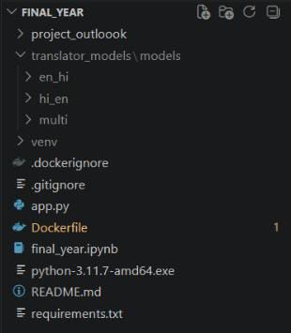
Fig 5.1 Directory Structure in VS Code

2. Frontend Interface (Streamlit UI)
The frontend of the system is developed using Streamlit, which provides an interactive chat-based interface.

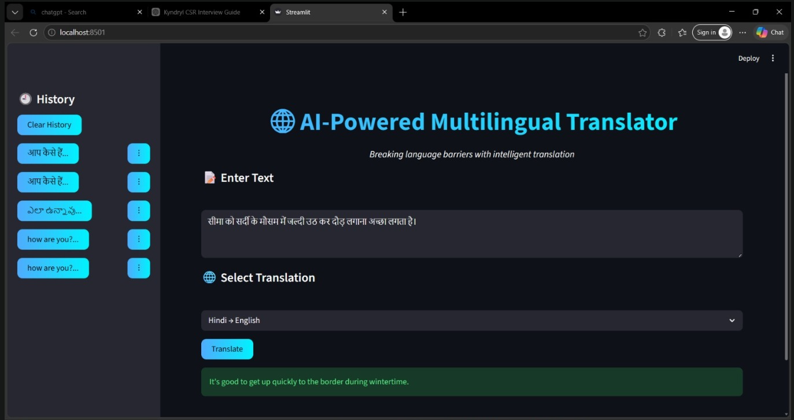
Figure 5.2: Chatbot Home Interface

3. Chatbot Working (User Interaction)
The system accepts user input and generates responses using a fine-tuned TinyLlama mod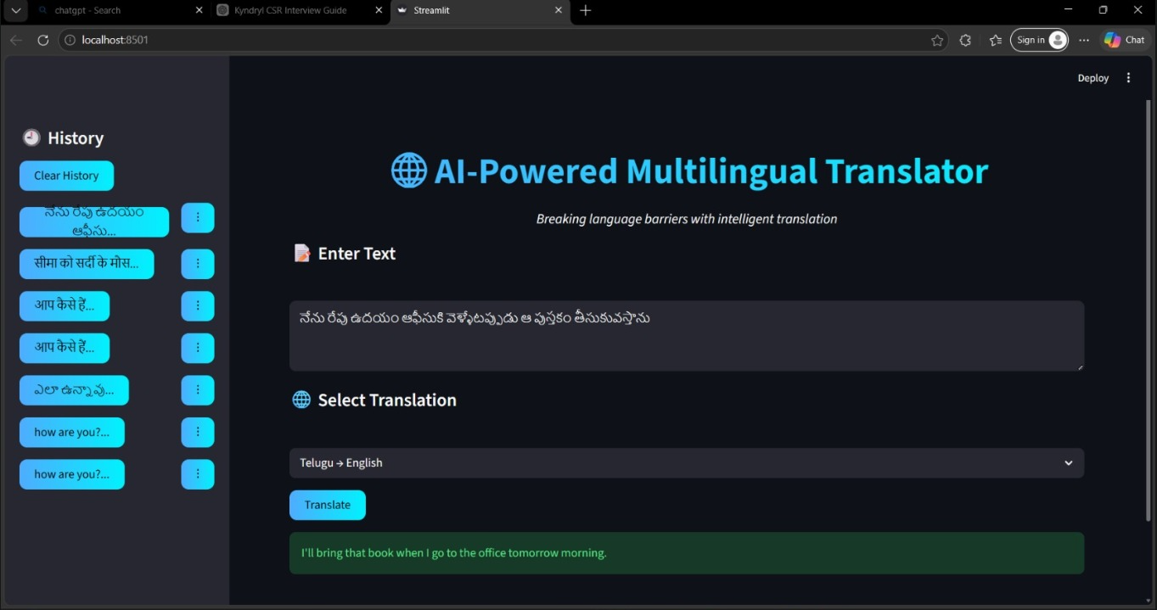 Figure 5.4: Crisis Detection Response

Example:
User:I am feeling happy today.
Bot: నేను ఈ రోజు సంతోషంగా ఉన్నాను

4. Crisis Detection Output
The system detects harmful or sensitive messages and provides safe responses.

5. Model Generated Output
The TinyLlama model generates contextual responses based on user input.

6. System Working Flow
The system follows the following workflow:
User Input → Language Detection → Preprocessing → Tokenization → Translation Model → Response Generation → Output Display

Conclusion for Output
The results obtained from the Multilingual Language Translation system demonstrate that the project successfully provides an efficient and user-friendly translation platform. The system allows users to input text in one language and receive accurate translations in their desired target language.
By using Natural Language Processing (NLP) techniques and advanced translation models, the system is able to understand the input text and generate meaningful translations while preserving the context and intent of the original message. The integration of language detection further enhances the system by automatically identifying the source language without user intervention.

The developed web application provides an interactive and simple interface, making it easy for users to communicate across different languages. This project highlights the importance and potential of Artificial Intelligence in breaking language barriers and improving global communication.

5.4 DISCUSSION

The developed Multilingual Language Translation system demonstrated effective performance in translating text between multiple languages. The system successfully integrates Natural Language Processing (NLP) techniques with a user-friendly web interface to provide accurate and meaningful translations.

5.4.1 Performance Analysis
The performance of the Multilingual Language Translation system is evaluated based on translation accuracy, response time, and system efficiency.

- Language Detection
The system effectively identifies the input language automatically using NLP techniques. This reduces user effort and ensures smooth translation without manually selecting the source language.

- Translation Accuracy
The system generates meaningful and context-aware translations. It performs well for common sentences and general communication, maintaining the intent of the original text. However, slight inaccuracies may occur for complex sentences or idiomatic expressions.

3. Response Generation
The translation model produces human-readable output in the target language. The responses are clear, understandable, and suitable for real-world communication.

- System Efficiency
The system performs efficiently with minimal response time, providing quick translations even without high-end hardware. The web interface ensures smooth and interactive user experience.

5.4.2 Error Analysis
Despite good performance, certain limitations and errors were observed during testing.
1.Misinterpretation of Complex Sentences
The system sometimes struggles with complex or long sentences, leading to slight inaccuracies in translation.

2.Issues with Idioms and Expressions
Idiomatic expressions and region-specific phrases may not be translated correctly, as their meanings differ from literal translations.

3.Grammar Inconsistencies
In some cases, the translated output may have minor grammatical errors, especially in less commonly used languages.

4. Language Detection Errors
Automatic language detection may occasionally misidentify the input language, especially when mixed languages are used

5.4.3 Comparison with Other Approaches

The Multilingual Language Translation system is compared with existing methods:

Method | Advantages | Disadvantages
Rule-based translation | Simple and fast | Limited flexibility and accurancy
Online translators(e.g. Google Translate) | High accurancy, supports many languages | Requires internet,less customizable
Proposed System | Automatic language detection | Limited accurancy for complex sentences

The proposed system provides a simple efficient solution suitable for basic translation neeeds

5.4.4 Practical Implications

The system has several real-world applications:
1.CommunicationTool
Helps users communicate across different languages easily.

2.EducationalUse
Useful for students to learn and understand different languages.

3.TravelAssistance
Helps travelers understand and interact in foreign languages.

4.BusinessCommunication
Supports basic communication in multilingual environments.

5.Real-TimeUsage
Can be used in chat systems for quick translation

5.4.5 Limitations and Challenges

Despite its effectiveness, the system has certain linitations :

1. Limited Context Understanding
The system may not fully preserve context in long or complex sentences.

2.DependencyonModel/Data
Translation quality depends on the training data and model used.

3. No perfect Accurancy
The system may produce approximate translations instead of exact ones.

4. CPU-Based Computation Limitation
Running on CPU may slightly reduce performance speed compared to GPU systems.

5. Limited Language Support
Only a few languages may be supported initially.

6. Delay in Processing Long Inputs
Long sentences may take more time for translation due to computational limits.

5.4.6 Future Work

Several enhancements can improve the system:

1.Advanced Deep Learning Models
Using transformer-based models for better accuracy.

2.Voice-Based Translation
Adding speech-to-text and text-to-speech features.

3.Real-Time Conversation Translation
Enabling live translation during conversations.

4.Mobile Application Development
Developing Android/iOS apps for accessibility.

5.Support for More Languages
Expanding to include more regional and global languages.

6.Improved Context Understanding
Enhancing the model to handle complex sentences better.

5.4.7 Ethical Considerations

The development of a translation system also involves ethical aspects:

1. Data Privacy
User input data should not be stored or misused.
2. Accuracy Responsibility
Users should be aware that translations may not always be perfect.
3. Fair Usage
The system should be used responsibly without spreading misinformation.
3.Transparency
Users should understand that the system is AI-based and not 100% accurate.

5.4.8 Key Challenges

The development process involved several challenges:
• Handling multiple languages effectively
• Ensuring accurate translation with limited resources
• Designing automatic language detection
• Maintaining balance between speed and accuracy
• Managing different sentence structures across languages

CONCLUSION

The rapid advancement of Artificial Intelligence (AI) and Natural Language Processing (NLP) has significantly transformed the way language translation systems are developed and used in real-world applications. With increasing globalization and communication across different regions, language barriers have become a major challenge. To address this issue, the project titled Multilingual Language Translation System was developed as an intelligent application that allows users to translate text from one language to another efficiently.

The primary objective of this project was to design and implement an AI-based translation system that can accurately convert text from a source language to a target language while preserving its meaning and context. The system enables users to input text through a web-based interface and receive translated output instantly, making communication easier and more effective.

The implementation of the Multilingual Language Translation system involved several stages, including language detection, preprocessing, tokenization, translation model integration, and user interface development. The system processes user input and generates translated output using Natural Language Processing techniques and machine learning models.

One of the key components of the system is the translation model, which is capable of generating context-aware translations. The automatic language detection feature further enhances usability by identifying the source language without requiring manual selection.
The project was implemented using the Python programming language due to its strong support for AI and NLP libraries. The backend integrates the translation logic with a web-based interface, providing a simple and user-friendly environment for users to interact with the system.

The Multilingual Language Translation system successfully demonstrates how artificial intelligence can be used to overcome language barriers and improve communication. It provides users with a platform to easily translate text, which is useful in education, travel, and business communication.

During the development of this project, several challenges were encountered. One of the major challenges was ensuring accurate translation for complex sentences and idiomatic expressions. Another challenge was optimizing the system to provide fast responses while running on limited computational resources. These challenges were addressed by improving preprocessing techniques and optimizing the model performance.

Although the developed system provides useful functionality, there are several areas for future improvement. One potential enhancement is the use of advanced deep learning models to improve translation accuracy and context understanding. Another improvement is the addition of voice-based translation to make the system more interactive and user-friendly.
The system can also be expanded by supporting more regional and international languages. Furthermore, developing a mobile application would increase accessibility and usability for a wider range of users.

Despite these limitations, the current implementation of the Multilingual Language Translation system provides a strong foundation for AI-based translation applications. The project successfully demonstrates the practical use of artificial intelligence in building efficient and user-friendly language translation systems.

In conclusion, the Multilingual Language Translation System represents an effective application of artificial intelligence and natural language processing in overcoming communication barriers. The system provides an interactive platform where users can easily translate text between languages, highlighting the importance of AI in improving global communication and connectivity.

APPENDIX
The appendix in a document serves as a supplementary section that provides additional information supporting the main content of the project report. It includes materials that help readers understand the technical implementation of the system but are not necessary to include in the main chapters.

These materials may include datasets, code snippets, algorithms, configuration details, and additional explanations related to the project implementation. The appendix provides a deeper understanding of how the system was developed and how the different components interact with each other

1. INTRODUCTION

The appendix provides supplementary technical information related to the implementation of the Multilingual Language Translation System. It includes system architecture, project structure, model details, and important code snippets used in the development of the project.
This section helps in understanding how the system processes user input and generates translated output using Artificial Intelligence and Natural Language Processing techniques.

The system is built using NLP-based translation models integrated with a web-based application. It is designed to translate text from one language to another efficiently and accurately, reducing communication barriers

2. DATA PREPARATION AND MODEL DETAILS
The system uses language datasets and pre-trained translation models for performing multilingual translation tasks.
Model Details:
- Model Type: Neural Machine Translation (NMT) Model (e.g., MarianMT / Transformer-based models)
- Framework: Hugging Face Transformers / NLP Libraries
- Processing Techniques: Tokenization, Text Preprocessing
Purpose:
- Improve translation accuracy
- Maintain context and meaning of sentences
- Support multiple languages
- Enable fast and efficient translation

- SYSTEM ARCHITECTURE
The system follows a simple pipeline:
User Input → Language Detection → Preprocessing → Translation Model → Response Generation → Output Display

✔ Modules:
- Input Layer: User enters text through web interface
- Processing Layer: Performs language detection and preprocessing
- Model Layer: Translates text using NLP model
- Output Layer: Displays translated text to the user

4. SYSTEM IMPLEMENTATION
The Multilingual Language Translation system was implemented using modern NLP techniques and web technologies to provide real-time translation.

Programming Language
Python was used as the primary programming language for implementing the system logic.

Web Framework
A web-based interface (such as Streamlit ) was used to develop the frontend of the translation system.
It provides:
- Simple text input interface
- Real-time translation output
- Easy user interaction
- Clean and user-friendly design

Frontend Technologies
- Streamlit / HTML & CSS (for UI design)
- Basic styling for better user experience
- These technologies help in creating an interactive and user-friendly interface.

Project Files
Important files used in the project include:

- app.py → Main application file that handles user input and displays translation output
- translator.py / model.py → Contains translation logic and model integration
- models/ → Stores pre-trained translation models
- utils/ → Helper functions for preprocessing and language detection
- pycache/ → Auto-generated Python cache files

5. IMPORTANT CODE IMPLEMENTATION

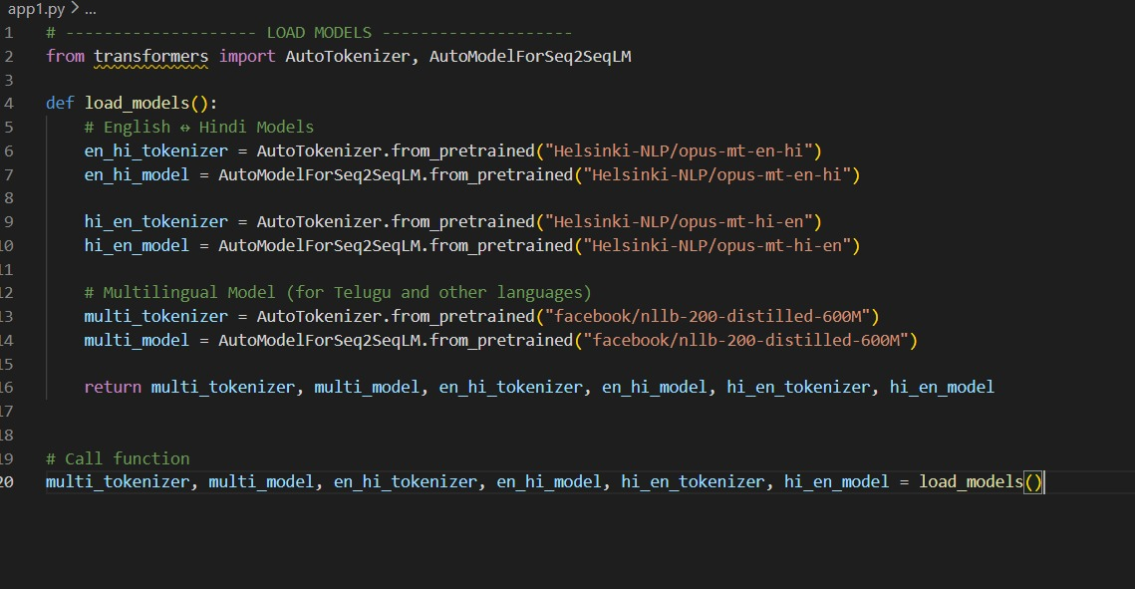

5.3ResponseGenerationFunction

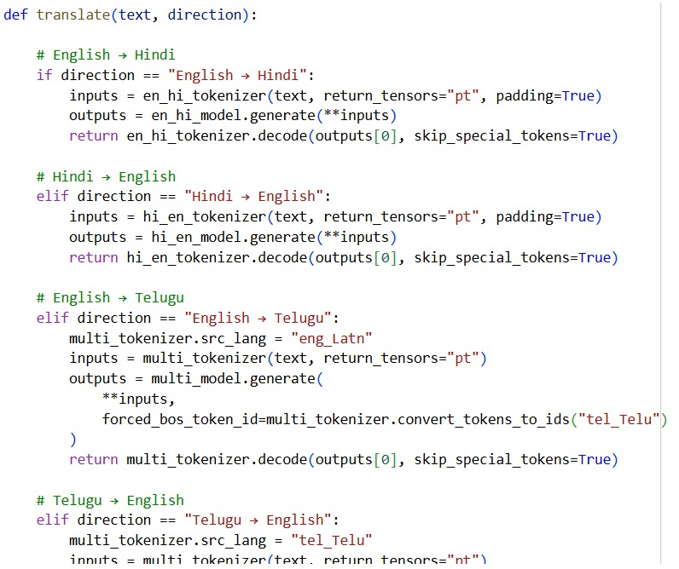

5.4 Streamlit Chat Interface Logic
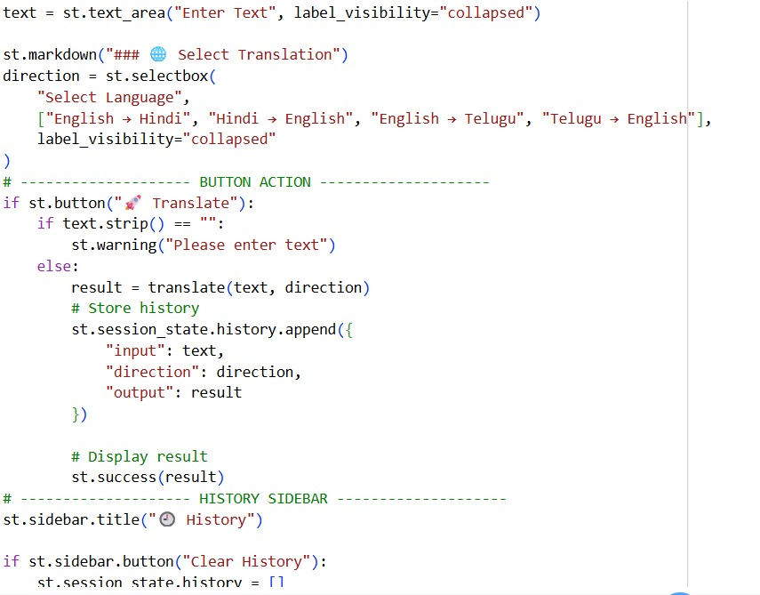

6. RESULT
The Multilingual Language Translation system successfully provides an interactive platform where users can input text and receive accurate translations in real time.

Key results include:
• Successful implementation of a web-based multilingual translation system
• Accurate translation of text between English, Hindi, and Telugu languages
• Effective use of NLP-based translation models for generating meaningful output
• Integration of automatic language handling for smooth user experience
• User-friendly interface with simple input and real-time output display
• Maintenance of translation history for better usability
• Fast response generation with efficient model execution

7. CONCLUSION
The Multilingual Language Translation project demonstrates how Artificial Intelligence and Natural Language Processing can be effectively used to overcome language barriers and improve communication between people speaking different languages.

The system allows users to input text in one language and receive accurate translations in another language through a simple and user-friendly interface. This helps users communicate easily, understand different languages, and access information without language limitations.

The project successfully integrates:
• NLP-based translation models (MarianMT / Transformer-based models)
• Automatic language detection techniques
• Tokenization and preprocessing methods
• Web-based user interface (Streamlit) to create an efficient and practical translation system.

Overall, the system showcases how modern AI technologies can be used to build accessible, scalable, and intelligent language translation solutions, contributing to better global communication and connectivity.

- FUTURE WORK
Several improvements can be made to enhance the Multilingual Language Translation system in future versions.

Voice-Based Translation
The system can be enhanced to support speech-to-text and text-to-speech features, allowing users to translate voice input in real time.

Mobile Application
The system can be developed as a mobile application to provide easy access for users anytime and anywhere.

Real-Time Conversation Translation
Future versions can support live conversation translation, enabling users to communicate instantly across different languages.

Support for More Languages
Adding more regional and international languages can make the system accessible to a wider range of users.

Improved Translation Accuracy
Using advanced deep learning and transformer-based models can improve the accuracy and context understanding of translations.

Offline Mode Support
The system can be enhanced to work offline with optimized models, making it usable without internet access.

9. ACKNOWLEDGEMENTS
We sincerely express our gratitude to all those who supported us in completing this project successfully.

We thank the developers and contributors of open-source technologies such as Python, Streamlit, Hugging Face Transformers, and PyTorch, which played a vital role in building this project.

We also extend our sincere thanks to our project guide Ms. K.V.Durga Devi, Assistant Professor in the Department of CSE – AIML, for her valuable guidance, support, and encouragement throughout the development of this project.

We also express our sincere thanks to the Head of the Department - Ms. M. Deepika and the Principal - Mr.Y.Rama Krishna for their support and for providing the necessary facilities to carry out this project.

Finally, we thank our institution Kakinada Institute of Engineering and Technology for Women for providing the resources and environment required to successfully complete this project.

